**AKS Cluster Creation**

1. Create a Resource Group

Note: Select region Southeast Asia or North Europe.

1. Create a Virtual Network and Subnet inside the RG

Note: Enable Public IP bastion under security tab.

1. Create a Virtual machine with below mentioned configurations

Note: Authentication -> SSH, Public inbound ports: None

Once VM created got to NSG and add new rule in inbound for SSH.

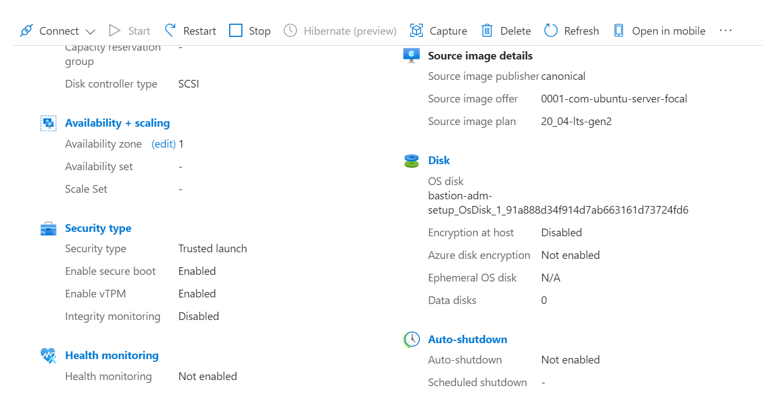

1. Create Azure Kubernetes service with below mentioned configurations.

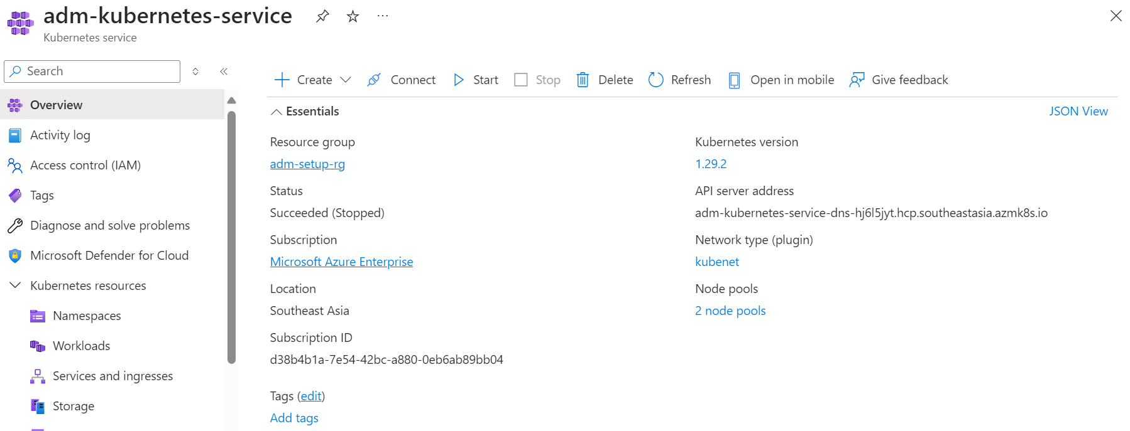

1. Connect to the bastion VM with Public IP and SSH key
2. Install azure-cli and login with azure creds

**sudo apt-get update**

**sudo apt-get install azure-cli**

**sudo az login --service-principal --username <client_ID> --password <client_secret> --tenant <tenant_id>**

**Create empty kubconfig file**

**vi <configfile>**

**export KUBECONFIG="/home/ubuntu/<configfile>"**

**sudo az aks get-credentials --resource-group <provision id> --name <provision id> --file <configfile>**

1. Install kubectl

**sudo snap install kubectl --classic**

1. Execute below command check whether nodes are ready

**kubectl get nodes**

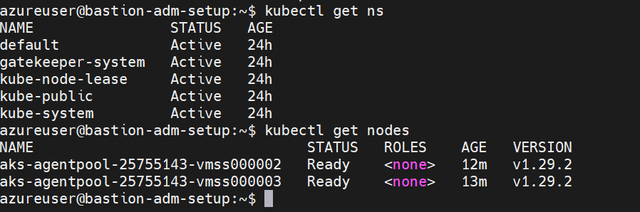

1. Deploy Sample application

Note: If application is deployed as loadbalancer and need to access open the particular port to vpn ip in aks created infra nsg.

Example:

**How to Install Ingress Niginx Controller**

* kubectl apply -f https://raw.githubusercontent.com/kubernetes/ingress-nginx/controller-v1.3.0/deploy/static/provider/cloud/deploy.yaml
* kubectl get pods --namespace ingress-nginx
* kubectl get service ingress-nginx-controller --namespace=ingress-nginx

Create a DNS record set

Create ingress.yaml and deploy

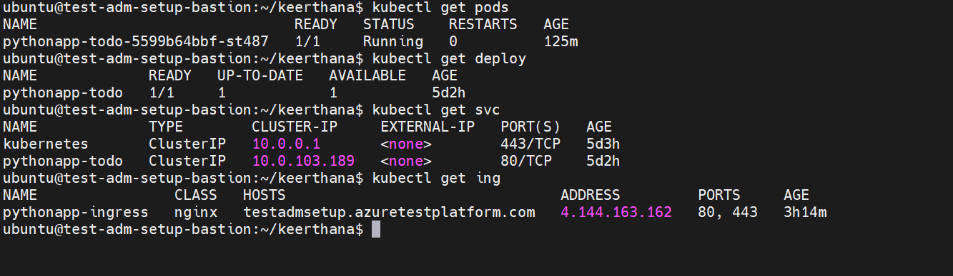

Try to access the application with DNS with http.

**How to make application secure by applying SSL (https)**

**helm repo add jetstack https://charts.jetstack.io**

**helm repo update**

**helm upgrade cert-manager jetstack/cert-manager \**

**--install \**

**--create-namespace \**

**--wait \**

**--namespace cert-manager**

This will create three Deployments and some Services and Pods in a new namespace called cert-manager. It also installs various cluster scoped supporting resources such as RBAC roles and Custom Resource Definitions.

You can view some of the resources that have been installed as follows:

**kubectl -n cert-manager get all**

**kubectl explain Certificate**

**kubectl explain CertificateRequest**

**kubectl explain Issuer**

**Create a ClusterIssuer and a Certificate**

# clusterissuer-selfsigned.yaml

apiVersion: cert-manager.io/v1

kind: ClusterIssuer

metadata:

name: letsencrypt-production

spec:

acme:

# The ACME production api URL

server: https://acme-v02.api.letsencrypt.org/directory

# Email address used for ACME registration

email: abc@gmail.com

# Name of a secret used to store the ACME account private key

privateKeySecretRef:

name: letsencrypt-production

# Enable the HTTP-01 challenge provider

solvers:

- http01:

ingress:

class: nginx

# certificate.yaml

apiVersion: cert-manager.io/v1

kind: Certificate

metadata:

name: tls

spec:

secretName: secret-tls

privateKey:

rotationPolicy: Always

commonName: testadmsetup.azuretestplatform.com

dnsNames:

- testadmsetup.azuretestplatform.com

usages:

- digital signature

- key encipherment

- server auth

issuerRef:

name: letsencrypt-production

kind: ClusterIssuer



